Final Report – Tableau Data Visualization & Dashboard Design
Sales Performance & Growth Opportunities Dashboard
Prepared by: Mukesh Samarit
Course / Module: Virtual Tableau Visualization internship
Date: 30 August 2026

Executive Summary
This report documents the end-to-end process of designing, developing, and optimizing a Tableau dashboard for sales performance and growth analysis. Over six weeks, the project progressed from initial data exploration and basic visualization to advanced analytical techniques, performance optimization, and interactive feature enhancement. The final dashboard, titled “Sales Performance & Growth Opportunities – Advanced Analytics,” integrates dual-axis charts, heat maps, calculated fields, and dynamic interactions to provide actionable insights for marketing and operations teams.
Key outcomes include:
- A clear understanding of the dataset’s structure, quality, and analytical potential.
- A well-structured dashboard that balances analytical depth with usability.
- Implementation of advanced visualization techniques and calculated metrics.
- Concrete performance optimization strategies and interactive enhancements.
- Reflections on lessons learned and recommendations for future improvements.
This report serves both as a comprehensive documentation of the project and as a portfolio piece demonstrating proficiency in Tableau visualization practices.

1. Introduction and Project Overview

1.1 Project Background
The project is based on an e-commerce order dataset containing fields such as order ID, order date, customer ID, product category, region, quantity, unit price, discount, payment method, delivery days, customer rating, and revenue. The business objective is to enable the marketing manager and operations team to:
- Understand revenue trends over time.
- Evaluate the impact of discounting on sales performance.
- Assess delivery performance and its relationship with customer satisfaction.
- Identify high- and low-performing region–category combinations.

1.2 Project Objectives
The overarching objectives of this project were to:
- Apply best practices in data exploration and dashboard design.
- Use advanced visualization techniques to reveal deeper insights.
- Optimize dashboard performance for scalability and responsiveness.
- Enhance interactivity to support self-service analysis.
- Document the entire process in a professional, structured manner.

2. Exploratory Data Analysis and Initial Insights

2.1 Data Understanding
The initial phase involved understanding the structure and quality of the dataset:
- Identifying key dimensions (region, product category, payment method, order date).
- Identifying key measures (quantity, unit price, discount, revenue, delivery days, customer rating).
- Checking for missing values, inconsistencies, and data types.

2.2 Key Exploratory Findings
Initial analysis revealed several important patterns:
- Revenue varies significantly across regions and product categories.
- Discount levels differ by month and region, suggesting targeted promotions.
- Delivery times show noticeable variation, with some region–category combinations consistently slower.
- Customer ratings are generally high but show meaningful variation that correlates with delivery performance.
These insights informed the selection of metrics and visualizations for the dashboard.

3. Dashboard Design and Data Narrative

3.1 Dashboard Structure and Layout
The dashboard was designed to tell a clear story:
- Top Section – Time-Based Trends
  - Dual-axis chart showing Revenue and Avg Discount by Month.
  - Provides a high-level view of sales performance and pricing behavior.
- Middle Section – Segment Performance
  - Bar and pie charts showing Revenue by Region.
  - Heat map showing Region × Product Category performance (Avg Customer Rating).
  - Enables quick identification of strong and weak segments.
- Bottom Section – Operational Insights
  - Scatter plot of Delivery Days vs Customer Rating.
  - Detail table with Delivery Performance Flag.
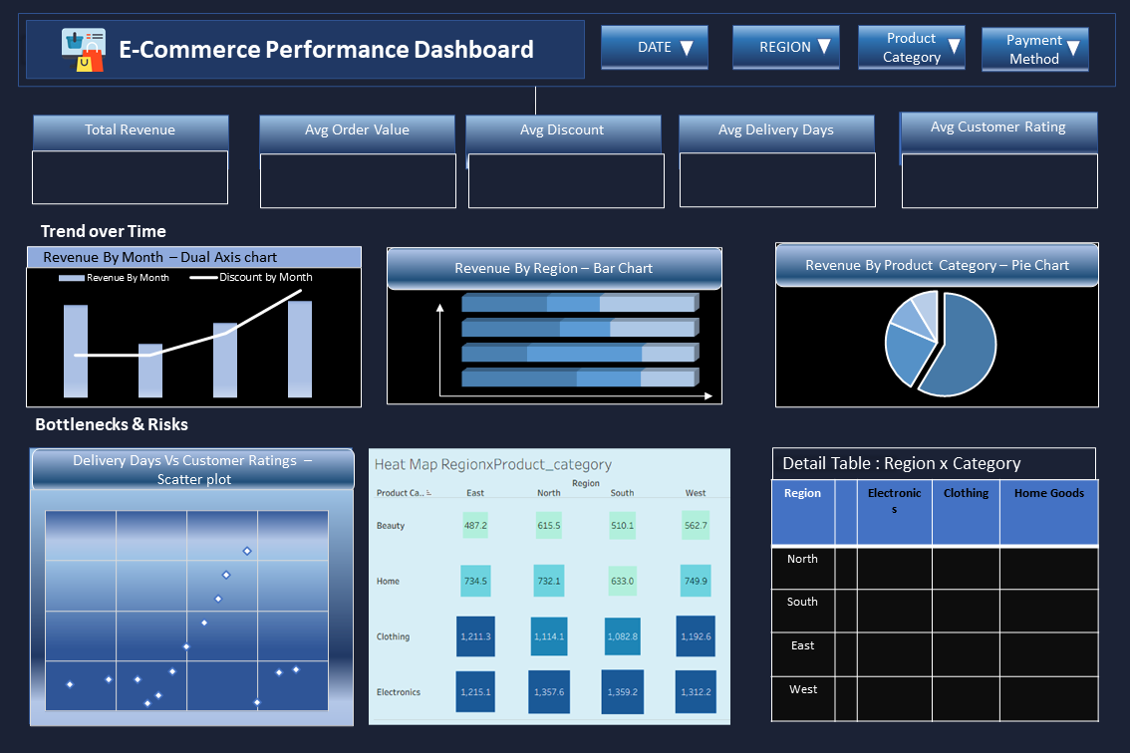
  - Links operational metrics to customer satisfaction.

3.2 Data Storytelling Approach
The narrative follows a logical flow:
- What is happening? (Revenue trends, discount patterns)
- Where is it happening? (By region and product category)
- Why might it be happening? (Relationship between delivery performance and ratings)
- What can be done? (Focus on underperforming segments, adjust discount strategies)
This structure ensures that the dashboard supports both monitoring and decision-making.

4. Advanced Visualization Techniques and Calculated Fields

4.1 Dual-Axis Chart: Revenue + Avg Discount by Month
A dual-axis combination chart was implemented to:
- Display Revenue by Month as bars.
- Overlay Avg Discount (%) by Month as a line on a secondary axis.
This reveals whether revenue peaks are associated with higher discounting, helping evaluate promotion effectiveness.

4.2 Heat Map: Region × Product Category Performance
A heat map was created to:
- Show Region × Product Category combinations.
- Use color intensity to represent Avg Customer Rating.
This provides an at-a-glance view of satisfaction levels across segments, highlighting areas needing attention.

4.3 Key Calculated Fields
Several calculated fields were defined to enhance analysis:
- Avg Discount %: AVG([discount])
- Delivery Performance Flag:
text
IF AVG([delivery_days]) <= 4 THEN "Good" ELSE "Poor" END
- MoM Revenue % Change (table calculation):
text
(ZN(SUM([revenue])) - LOOKUP(ZN(SUM([revenue])), -1))
/ ABS(LOOKUP(ZN(SUM([revenue])), -1))
These metrics transform raw data into decision-ready indicators.

5. Performance Optimization and Interactive Feature Enhancement

5.1 Performance Optimization Strategies
To ensure scalability and responsiveness, the following strategies were proposed:
- Data Source Optimization
  - Convert to Tableau .hyper extracts.
  - Apply date and segment filters at extract level.
  - Remove unused columns.
- Calculation Optimization
  - Optimize LOD expressions.
  - Simplify table calculations.
  - Precompute stable flags where possible.
- Dashboard Design Optimization
  - Reduce number of marks by using aggregated views.
  - Use context filters for frequently used dimensions.
  - Move highly detailed tables to a separate tab if needed.
Expected outcomes include faster load times, smoother interactions, and better scalability with growing data.

5.2 Interactive Enhancements
To improve user engagement, the following interactive features were proposed:
- Dynamic Parameters
  - Date range selector (Last 3/6/12 months, YTD).
  - Metric selector for heat map (Avg Rating, Avg Delivery Days, Avg Discount).
  - Delivery performance threshold parameter.
- Drill-Down Capabilities
  - Hierarchies: Region → Product Category; Year → Quarter → Month → Week.
  - Enables users to move from high-level to detailed views seamlessly.
- Dashboard Actions
  - Filter actions from heat map to dual-axis chart.
  - Highlight actions across views for cross-comparison.
These features empower users to explore data dynamically and answer their own questions.

6. Critical Evaluation of Approaches and Design Decisions

6.1 Effectiveness of Visualization Choices
The selected visualizations effectively balance complexity and clarity:
- The dual-axis chart successfully reveals the relationship between revenue and discounting without requiring multiple separate charts.
- The heat map provides an intuitive, color-coded performance map that is easier to interpret than a raw table.
- Supporting views (bar/pie charts, scatter plot, detail table) complement the advanced charts without overwhelming the user.

6.2 Impact on Data Storytelling
The dashboard’s structure supports a clear narrative:
- Users can quickly grasp overall performance (top section).
- They can then identify where issues or opportunities lie (middle section).
- Finally, they can investigate operational drivers and detailed data (bottom section).
This logical flow enhances comprehension and actionability.

6.3 Performance and Usability Trade-Offs
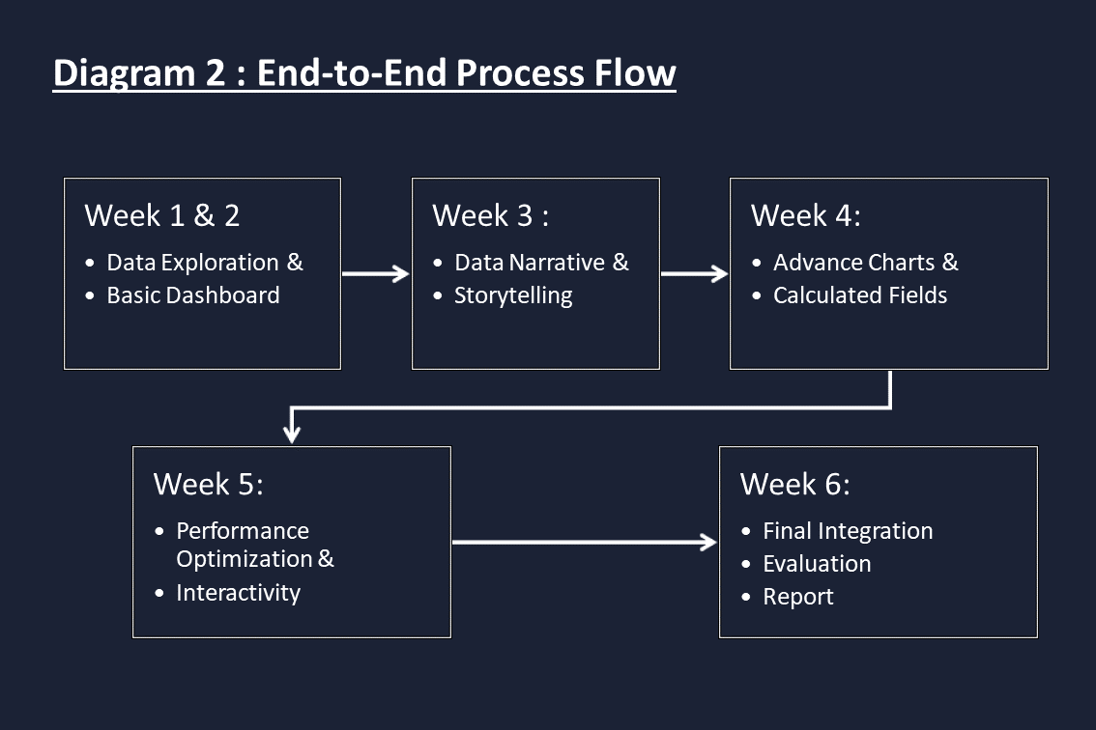
While the dashboard includes multiple views and calculations, the proposed optimization strategies ensure that performance remains acceptable. The use of parameters and actions adds interactivity without significantly increasing complexity for end users.

7. Lessons Learned
Throughout this project, several key lessons emerged:
- Start Simple, Then Add Complexity
  - Beginning with basic charts and gradually introducing advanced techniques helped maintain clarity and avoid over-engineering.
- Design with the End User in Mind
  - Every chart and calculation was evaluated based on whether it answered a clear business question.
- Performance Matters as Much as Insights
  - A visually rich dashboard is of limited value if it is slow or unresponsive. Optimization must be considered from the outset.
- Documentation Is Part of the Solution
  - Clear documentation of calculations, layout, and interactions makes the dashboard more maintainable and easier to hand over to others.
- Iterative Improvement Is Key
  - Each week’s task built on the previous one, allowing continuous refinement of both the dashboard and the underlying analytical thinking.

8. Recommendations for Future Enhancements
Based on this project, the following enhancements are recommended for future iterations:
- Incorporate Profit and Margin Metrics
  - If cost data becomes available, add profit and margin calculations to provide a more complete financial picture.
- Expand Drill-Down to Product Level
  - Extend hierarchies to include product sub-category or product name for deeper granularity.
- Introduce Forecasting
  - Use Tableau’s forecasting features to project future revenue and discount trends based on historical patterns.
- Integrate Real-Time or Near-Real-Time Data
  - Connect to a live database or scheduled extracts to keep the dashboard up to date with minimal manual intervention.
- Develop Role-Based Views
  - Create separate dashboard tabs or versions tailored to different user roles (e.g., marketing manager vs. operations manager).
- Add Mobile-Optimized Layouts
  - Design a mobile-specific layout to ensure accessibility for users who primarily access dashboards on phones or tablets.

9. Reflective Conclusion
This virtual internship experience has significantly enhanced my understanding of end-to-end Tableau dashboard development. From initial data exploration to advanced analytics, performance tuning, and interactive design, each phase contributed to a holistic skill set.
Key takeaways include:
- The importance of aligning visualizations with business objectives.
- The value of advanced techniques when used purposefully, not just for complexity.
- The critical role of performance optimization in real-world deployments.
- The power of interactivity in transforming a static report into an exploratory analytics tool.
Challenges encountered—such as balancing detail with performance, and choosing the right level of interactivity—were valuable learning opportunities. Moving forward, I plan to apply these lessons to more complex datasets and business scenarios, continuing to refine both technical and storytelling skills.
This project not only demonstrates proficiency in Tableau but also reflects a structured, user-centered approach to data visualization that I intend to carry into future professional work.

